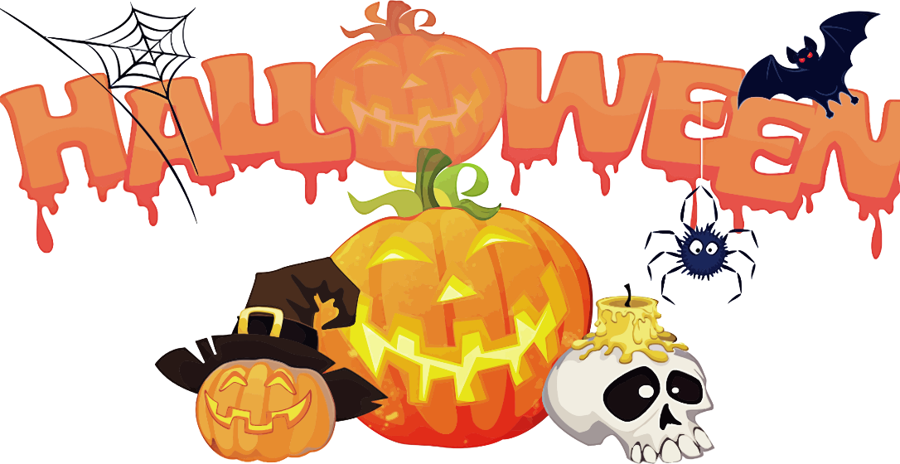

Halloween is a fun time for all in a school and we want to celebrate as a Father Leduc family. We ask that students bring their costumes to school and get dressed in their costumes after lunch break. If parents choose to come help students get dressed, they are welcome to join us after 12:15 pm.

Elementary students will have their classroom celebrations after we gather as an elementary school for a fun parade at 12:45. Students in Kindergarten to grade 6 will be participating in the parade. Please invite your family members if they wish to come watch the parade in the gym.

**In alignment with our Safe and Caring mandate, we ask that all students adhere to our fear friendly policy – students wearing inappropriate costumes or costumes with blood will be asked to remove them. We have students participating in the parade from the age of 4-12, therefore, we wish to create a safe and comfortable environment for all. If you are unsure of your costume, please ask your child’s teacher or school administration.**

We hope to see you there!

Our social justice group is promoting “Scare Away Hunger.” Please consider sending your child with an item for the food bank for the Halloween party to add to our collection. Parents coming for the parade are invited to dress up and bring a food bank donation as well!