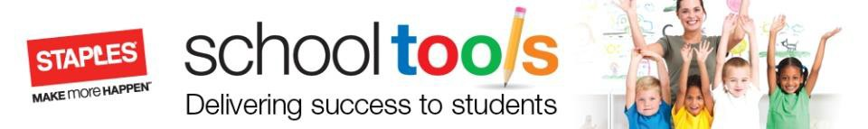

Dear Parent,

Father Leduc has partnered with STAPLES to offer student's parents the opportunity to pre-purchase their school supplies for the upcoming school year.

THIS IS A VOLUNTARY PROGRAM but one that we are sure will be of value to you by providing students with quality school supplies that meet their exact needs.
Student supply lists were created by the teachers at Father Leduc. All products are high quality and offer exceptional value for parents. All purchases are guaranteed for the school year and are eligible for replacement at STAPLES, should you require an immediate replacement. Please note that all prices include GST. Personal items such as inside shoes, backpacks, school fees etc. are not included. All of the Staples supply packages offer exceptional value for parents while ensuring all the students have the right tools for success!
Please note: individual teachers may request additional supplies.

Students are offered two options to purchase school supplies for 2017-18 school year
Have choices between “Standard” or “Premium” package.
STANDARD PACKAGE | PREMIUM PACKAGE
Includes basic core stationary items only. Students MUST bring all additional items such as (rulers, scissors, calculators, etc) on the first day of school. | Includes ALL of the stationary supply items required for the school year.

ORDER ONLINE: Supply orders can be made with through the staplesschooltools.ca website (instructions attached) The deadline for online ordering will be July 31, 2017.
PAY IN STORE: The order form is included in this package. Please complete the attached form and drop by any Staples store.
IN PERSON: A hard copy of the supply list will be sent home with every student if you wish to shop in person for the items.
Supply packages will be delivered to the school and ready for pick up August 25th.

Please be sure to send supplies to school on September 5th, 2017.

Questions regarding orders contact: Email Jay Evans, Jay.Evans@staples.ca
STAPLES Meadows
2012 38th Ave Edmonton T6T 0B9 780.442.0316 ext. 641

In addition to the mentioned benefits above, we have included the following bonus offers for those parents ordering before July 8th

- A sheet of labels to allow you to identify all your child’s supplies
- Staples Coupon for $20 of $100 purchase in store
- Free Oliver Label Coupon

GRADE | STANDARD |  | PREMIUM
ECS GIRL | 82D0585A-92304 |  | C037BD92-92310
ECS BOY | 1F15B3EC-02772 |  | 96BD06F7-02773
1 | 60E541C9-02774 |  | C33B43A1-02775
2 | B30FAD1E-02776 |  | 99FB1501-02777
3 | 46A8D47B-02778 |  | 8EC55048-02779
4 | 765527F6-02780 |  | BC438CE6-02781
5 | 60C20BBF-02782 |  | 36FFEA9F-02783
6 | 89A2F07B-02784 |  | 5F809E2B-02785
7 | E5F656DC-02786 |  | 380589AD-02790

